**Setup steps:**

1. From GIT Folder.

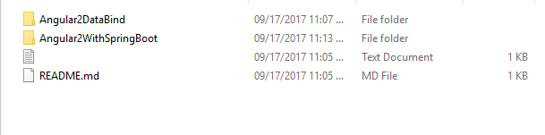

Angular2(Front End/Client side) code: Angular2DataBind

1. Once code Check out from the GIT. Open Nodejs command prompt which is installed on your machine and pointing to angular project like below.

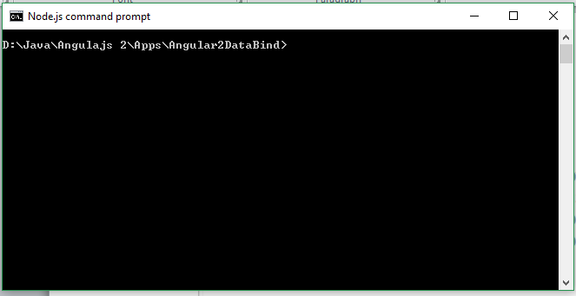

1. Run ‘npm install’ and it will download the node_modules for the project.

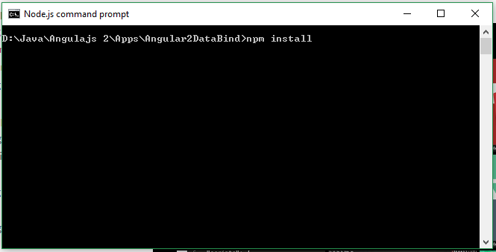

1. Once done the project folder will get the node_modules.

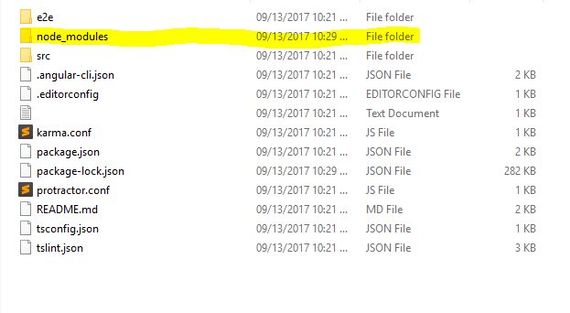

1. Once get the modules folder run the application like below.

npm start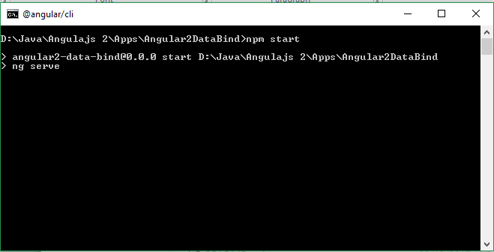

1. Go to Spring boot application as Angular2WithSpringBoot



1. Import the project into Eclipse/(any other IDE).

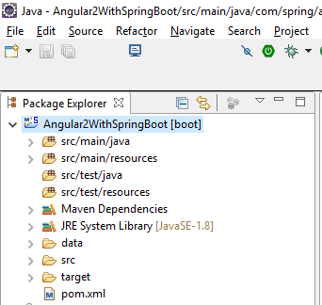

Below step is to run for spring boot application.

Open SpringBootExample.java file and run as spring boot application/java application/(Alt+Shift+X, B)

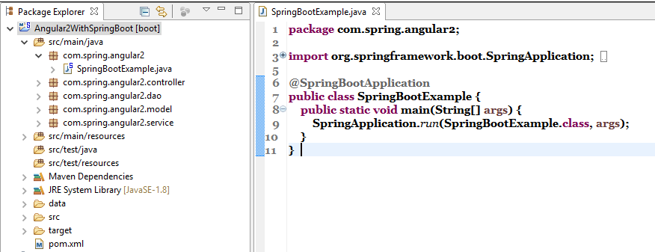

Server running console like below

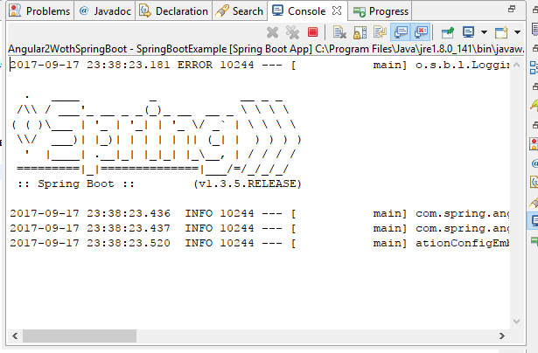

For Angular application default running URL: <http://localhost:4200/>

